PRESS RELEASE – FOR IMMEDIATE RELEASE AFTER MAY 22nd 2021
“Naïve” is an ode to radical dreamers
Singer-songwriter Petra Jasmiina is known for her signature style of lyrical story pop, and her upcoming single, “Naïve” is an oasis of just that. The song takes us deep into a paradoxical fairytale where starry-eyed dreamers and hopeless romantics no longer need to hide away. In a world where tough realism and hard facts rule, she anoints herself Queen of reckless daydreaming, wild romanticism and shameless innocence - and invites you to join her court.
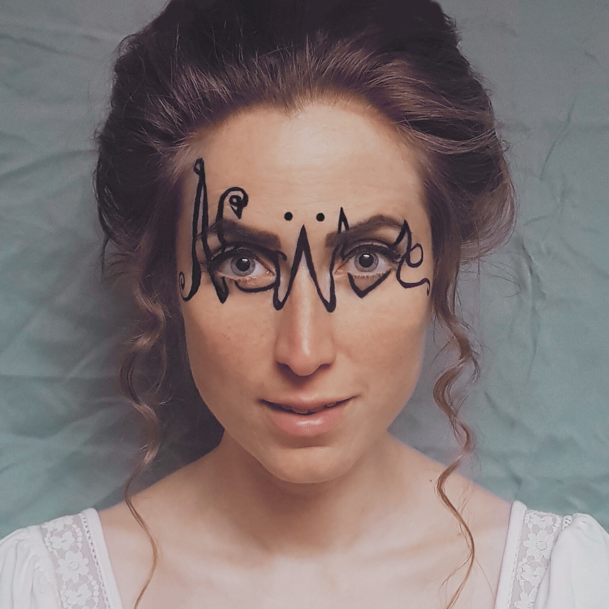
Naïve is a delicious paradox. The world of sound, a pearly fairytale with a dark undertone, is a debut production by the Finnish, New York City-based artist herself – a fresh and unique duality of indie and electropop. The songwriting bears Petra’s signature flairs of poetry, personality and storytelling and is described by the independent artist as excruciatingly autobiographical; In admiration of Lorde’s “Liability” and Taylor Swift’s “Blank Space”, the song was born out of turning hurtful critique into praise by switching the narrative – in this case, owning and embracing her inner dreamer, a starry-eyed romantic and shameless idealist. By stepping into the light as “a naïve” she invites the listener to claim the title as well – and share the throne.
According to the artist, the song comes with a mission. “I want to give people permission to dream. To open their minds to wide-eyed wonder, infinite possibility and their innate creativity and imagination, often lost and forgotten in adulting. I want chasing your dreams to be the rule, not the exception, for romance to be put back on its pedestal and for believing the best of people to be a strength, not a weakness. Or, as the song put it: ‘I’ve been waiting for so long to dream with you.’ “
Naïve is out on all platforms June 4th and is now available for Spotify pre-save here:
Naïve by Petra Jasmiina - DistroKid
The “Dreamer’s Editions” with alternate versions and other exclusive fan gifts are now available for pre-order at Musician | Petra Jasmiina
Follow Petra on Spotify: https://open.spotify.com/artist/2Iflm2l1qluNQJk64jZNxz?si=sf7C7jKxT0iPHf-lpNBKXA
Follow Petra on Apple Music: https://music.apple.com/us/artist/petra-jasmiina/1480245288
Follow Petra on Amazon Music: https://music.amazon.com/artists/B07Y2F6JV7/petra-jasmiina?marketplaceId=ATVPDKIKX0DER&musicTerritory=US
Follow Petra on Instagram: https://www.instagram.com/petrajasmiina

